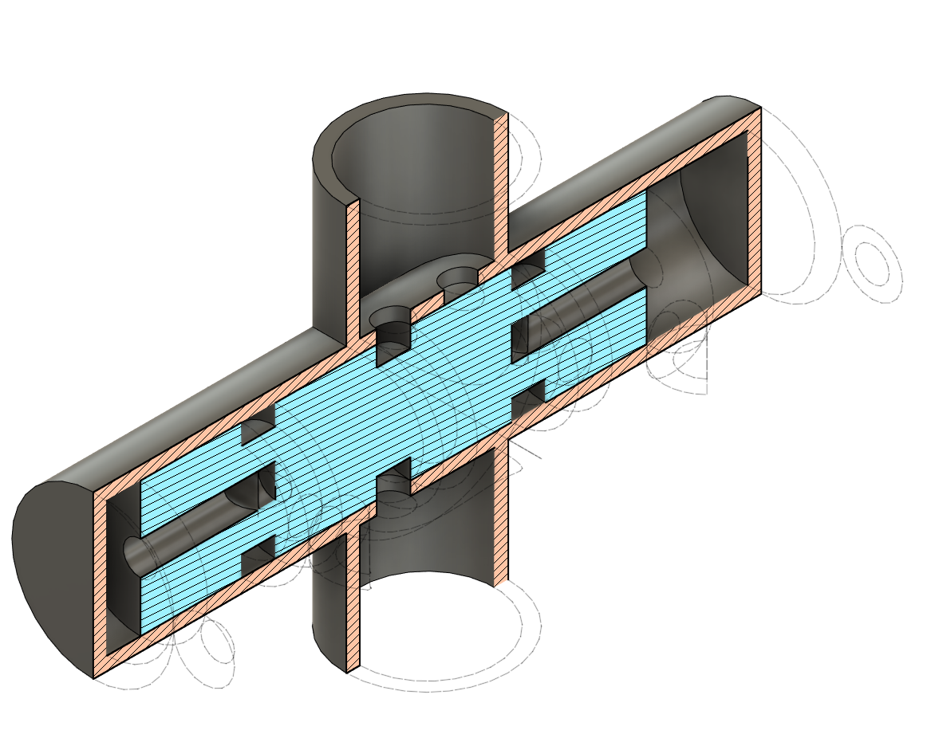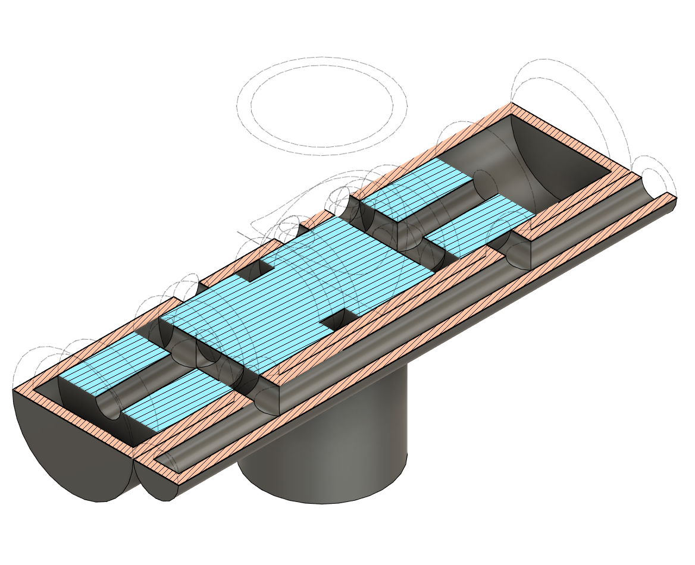

Connections

Top - to patient manifold
Bottom - to pressure bag
Right (small port) - to needle valve controlling cycling speed
(this is shown during inhale; during exhale the piston moves to the opposite side)

How it works

In either piston position: pressure is building up through the needle valve at a controlled rate to flip it to the other position. The other side of it is open to the atmosphere so it won't create a force in the opposite direction

The piston needs some kind of retaining feature at each end - this could be a buckling spring with two positions, a catch, or magnets. Magnets are most likely to have a predictable and repeatable holding force

After the pressure builds above the holding force, the piston flips to the other side (quite fast), the pressure behind it vents to the atmosphere, and the cycle repeats in the opposite direction

Implementation notes

Steel piston; magnets at either end
Plastic tube (polycarbonate or K resin, injection molded)
Adjustable piston end-stops to control timing (and cushion)

Rough operating parameters

Operating pressure 2-5 psi
Flow 30-50 ml/minute
Holding force at each end 1-2 lbf (should be significantly more than piston friction)
Piston area 3 cm^2
Open port 0.2 cm^2 (can be increased somewhat, or just scale up the whole thing)

